Hydrogen Fuel Cell in HELC:
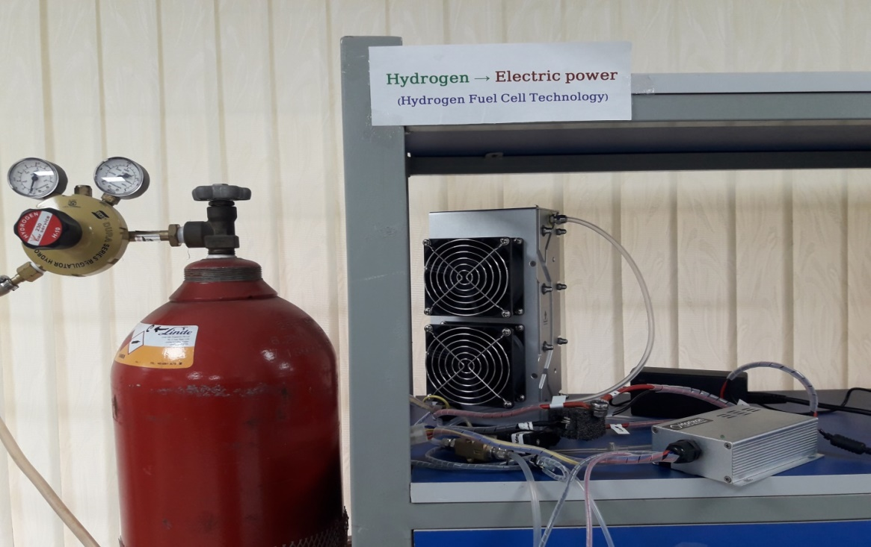
Fuel Cell is like a battery in that it generates electricity from an electrochemical reaction. A fuel cell performs the opposite process of an electrolysis cell. Water is formed from hydrogen and oxygen gases and electricity is generated. Fuel cell consists of two electrodes, and electrolyte, a separator, and an external electrical circuit. In addition fuel cells are generally constructed in a stack arrangement with planar electrodes and hydrogen fed at the anode where it loses electrons. The electrolyte is an electrical insulator, but has high ionic conductivity. Such ions are typically (cation) or (anion) charged atoms, or molecule that represents the mobile species in electrochemical reactions. An external circuit is attached to the anode which is negative electrode of the system where the reactant (fuel) is oxidized. The oxygen is fed at the cathode side where it receives electrons. The oxidized (anode) reactant, i.e. cations are transported away from the anode through the electrolyte to the second electrode called “cathode” due to the potential gradient (migration) and the concentration gradient (diffusion). The cathode is the positive electrode in the electrochemical system, where the oxidant is reduced. Water is formed from protons and oxygen ions either at the anode or the cathode side, depending on the fuel cell type. The separator ensures separation of the anode and cathode reactants to avoid direct chemical reaction and further prevent a direct electronic contact between the anode and cathode.
There are eight main types of fuel cells. Most of the fuel cell types are fed with hydrogen fuel. There is also direct ammonia and direct methanol fuel cells. In addition, methane (natural gas) through reforming can be used as fuel in solid oxide fuel cells.
Types of Fuel Cell
Proton exchange membrane (PEM) | 60-140℃ | Use hydrogen fuel
Alkaline (AFC) | 150-200℃ | Use hydrogen fuel
Phosphoric acid (PAFC) | 150-200℃ | Use hydrogen fuel
Molten carbonate (MCFC) | 600-700℃ | Use hydrogen fuel
Solid Oxide with proton conduction(SOFC+) | 200-700℃ | Use hydrogen fuel
Solid Oxide with oxygen ion conduction(SOFC-) | 1000-1200℃ | Use hydrogen fuel
Direct methanol (DMFC) | 30-80℃ | Use other fuel
Direct ammonia (DAFC) | 400-700℃ | Use other fuel

The applications of Hydrogen Fuel Cell systems are versatile in variety of sectors, for example to power motors, for combined heat and power generation and for electricity generation for range of scales.
Fuel Cell Applications
Power generation:  - Stationary  - Mobile  - Automotive  - Backup power  - Auxiliary  - Portable  - Distributed | Propulsion for Transportation:  - Auto vehicles  - Specialty Vehicles  - Buses, trains, etc. | Multi-generation (power, heating, water, oxygen, etc.):  - District power and heating  - Remote power heating and water  - Industrial power, heating and oxygen | Special applications(military, aerospace, medical):  - Water generation  - Pure oxygen production

Hydrogen energy laboratory, Chattogram is focusing on Proton Exchange Membrane Fuel Cell (PEMFC). The particular aspect to this type of cell is represented by the solid polymer electrolyte, usually denoted as a proton-conducting membrane. The electrolyte is very thin and allows for proton conduction through hydronium ions when the membrane is wetted. The simplified representation of PEMFC and the half reactions at the fuel cell electrodes are shown below:
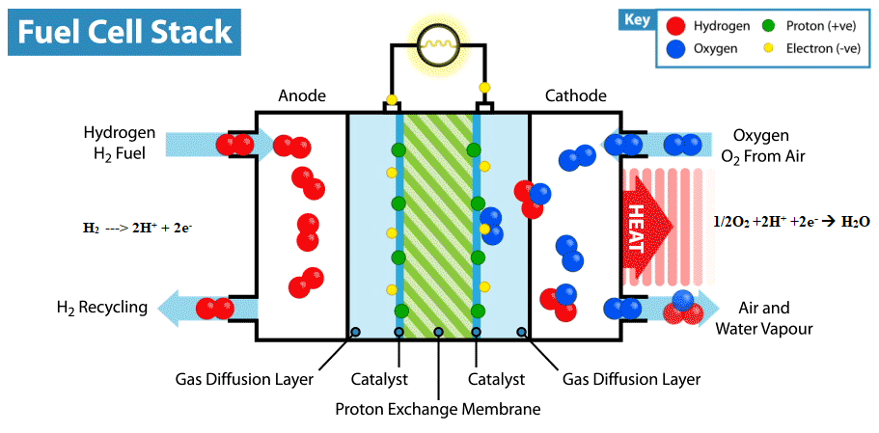

For electrolyte, a polystyrene sulfonate polymer (PSP) can be used; however, the proprietary membrane from DuPont- Nafion, which consists of a polytetrafluoroethylene (PTFE)- is proven to be more stable and has better conductivity.
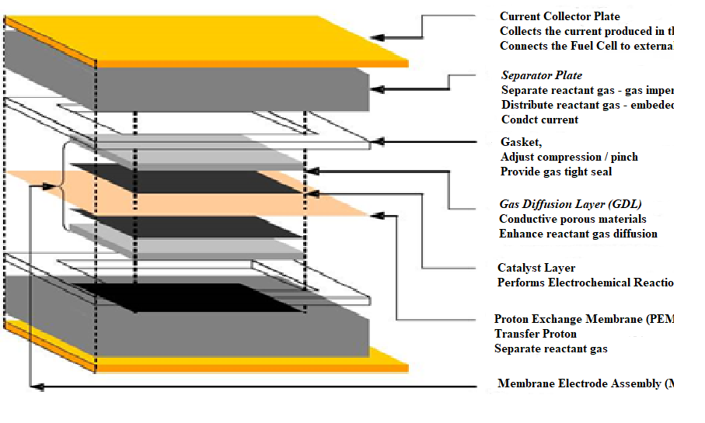
If we take a look at the inner design of the fuel cell stack PEM is constructed in a sandwich-like architecture with Current collector plate, Separator plate, Gasket, Gas diffusion layer (GDL), Catalyst layer, Proton exchange membrane (PEM), Porous planar electrodes forming a so-called membrane-electrode assembly (MEA). To accelerate both Oxidation and Reduction reaction, noble metal catalysts (such as Platinum, Palladium, Transition metal etc.) must be coated to the electrodes. To find low-cost, efficient catalysts and durable proton exchange membrane is our main challenge to build a sustainable earth with hydrogen energy.

