Hydrogen Distribution and Dispensation Research Division
About
Hydrogen is one of the most promising candidates for future transportation fuel. Shifting from conventional petroleum oriented fuel to hydrogen in the transportation sector is one potential direction as utilization of hydrogen with fuel cells may offer many advantages over the existing system. Hydrogen is a type of high-quality carbon-free energy carrier which exhibits high efficiency and low GHG emissions. Considering the long term impact of hydrogen for energy and transportation, it would be a primary source that leads the global energy system of the future. A remarkable progress of hydrogen production technologies has been made in recent years that open new era and support to design future energy infrastructure. Though, the technology requires a good support to materialize as a whole.
Infrastructure issues pose more challenges for hydrogen production and distribution than other alternative fuels such as biofuels and alcohol fuels. A key challenge of developing a future commercial hydrogen economy is how the infrastructure will be best designed and operated as time progresses, given that numerous technological options exist and are still in development for hydrogen production, storage, distribution and dispensing.
Distribution and dispensing are two essential steps in the supply chain of hydrogen. Hydrogen distribution and dispensing goals are based on the necessity to transport hydrogen from the point of production to the point of consumption. The goals of Hydrogen Distribution and Dispensing Research Division are as follows:
Advance research aiming the development of cost effective, energy efficient and safe hydrogen delivery systems. Evolution of new hydrogen distribution and dispensing related technologies that will help establishing hydrogen as an energy carrier for transportation and stationary power systems.
The current delivery options are tank trucks and pipelines carrying liquefied or compressed hydrogen, along with intermediate storage tanks and dispensing equipment. Major issues surrounding the distribution and dispensing infrastructure is large overall energy use during delivery, uniform codes and standards, and right-of-way approvals. Hydrogen delivery at the dispensing sites or filling stations is complicated particularly because this is where the consumer interface with the hydrogen takes place. The only long-term solution to the delivery problem may be to transport the hydrogen in liquid or solid form, using chemical hydrides or other compounds (e.g. methanol) as carriers. Alternatively, the transition technologies, such as electrolysis, might continue to be used.
The principal challenges are to develop a hydrogen appliance with demonstrated mass producibility and capable of operation in service stations and possibly at homes. The appliance would have to operate reliably and safely with only periodic surveillance by relatively unskilled personnel (station attendants and consumers). It would be the critical component of the integrated, standardized fueling facilities essential for a hydrogen transition.

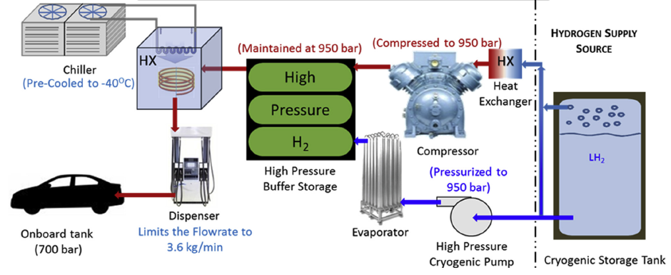
Figure: Representation of hydrogen distribution and dispensation. ^{[1]}

[1] Reddi K, Elgowainy A, Rustagi N, Gupta E. Impact of hydrogen refueling configurations and market parameters on the refueling cost of hydrogen, Int J Hydrogen Energy 2017;42(34):21855-65.

